# **Context of the application domain**

In a hospital, there are rooms designed specifically for the purpose of performing specific surgeries. With our simulation project, we want to test different procedures that will schedule surgeries, allocating them to operating rooms. We will focus on vascular surgeries.

Each operating room is available for a number of hours per days, to which surgeries can be allocated.

There are some degrees of urgency associated with each patient’s surgery and urgent cases need to be attended faster than others. In Portugal, there are 3 levels of urgency for vascular surgeries:

* **Level 1 -** normal.
* **Level 2 -** urgent.
* **Level 3 -** very urgent.

Sometimes, to schedule urgent cases in a desirable timeframe to avoid casualties, other surgeries might need to be rescheduled.

Each surgery is conducted by a head surgeon, who schedules the surgery. In a real life scenario, there is also a medical team composed of anaesthetists, other surgeons and nurses, however, for simplicity purposes, we will assume in our system that all this staff doesn’t need to be allocated specifically to a surgery. There will always be enough staff available during the operating rooms’ hours.

# **Problem statement**

Surgeries are stressful. The thought that a surgery might go wrong often haunts patients waiting for surgeries, leaving them in an undesirable mental state. In order to reduce the effects of stress accumulated in patients, it is crucial to minimize the time that a patient needs to wait to have surgery.

On top of this, surgical interventions are responsible for 52% of all admissions to the hospital and account for more than 40% of the total expenses of a hospital [2]. Since most of these costs are associated to salaries paid to surgeons and other staff which are at the hospital at fixed schedules, these costs can be minimized by maximizing the use of the operation rooms available [1].

# **Motivation to tackle the problem**

As the surgery allocation has been such a significant problem in society, to the point where there was a need to create waiting lists, where surgeries are put on hold for an undetermined amount of time. We want to improve the patients’ life quality by conceiving the best possible solution to allocate surgeries by minimizing waiting time and, consequently, stress levels and even possible casualties.

# **Research/Simulation questions & hypothesis**

* Which is the best scheduling procedure, when it comes to patient’s waiting time and operating rooms’ use rate?
* If there are more operating rooms or surgeons, the waiting time becomes shorter and the usage rate becomes smaller.
* If there are more patients, the waiting time becomes longer.
* Does an increase in operating rooms help hospitals increase their capacity to respond to patients’ surgery needs in a desirable time frame? What about an increase in surgeons?

# **Expected contributions**

Our project should contribute to:

* Society, by optimizing the surgery scheduling process which results in a reduction in waiting time, contributing to lower stress levels of patients and consequent improvement of life quality.
* Hospitals, by reducing the costs associated with surgical interventions.

# **Aim and goals of the project**

With the stated problems in mind, we devised this simulation project with the purpose of optimizing the allocation of surgeries to operating rooms and with the more specific goals of:

* Minimizing waiting time for surgery.
* Minimizing costs associated with the use of operating rooms.

# **Variables and respective domains**

The **system** will have the following overall variables:

* Number of patients.
* Number of operating blocks.
* Number of available surgeons.

Each **surgery** will contain the following variables:

* Urgency Degree, integer between 1 and 3.
* Duration, in minutes.
* Head Surgeon.
* Operating room, which will be allocated during the execution of the simulation system.

Each **operating** **room** will contain the following variables:

* Number of hours that an operating room is available in a day.
* Schedule: bidimensional array, where each column represents a day and inside each day, there are the surgeries scheduled for the day.

Each **surgeon** will contain:

* Schedule: bidimensional array, where each column represents a day and inside each day, there are the surgeries scheduled for the day.

# **Assumptions and premises**

* The patients arrive to schedule a surgery following a linear distribution.
* Other than the head surgeon, all the medical staff needed for a surgery doesn’t need to be allocated specifically to a surgery. We assume that there is always enough staff available during the operating rooms’ hours.

# **Constraints and limits**

* Each occupation room has a limit number of hours that it can be used in a day.
* Each surgeon can only be in one surgery at a time.

# **Cost/utility functions**

The **Average Waiting Time**, expressed in days, has the following formula:

$$Average Waiting Time=\sum_{p=1}^{n}{\frac{{WaitingTime}_{p}}{n}}$$

Where:

* ***n*** is the total number of patients in the system.
* ***WaitingTime*** is the number of days, between the patient p’s surgery scheduling and the actual surgery.

The **Occupation Rate** of an operating room, in percentage, is obtained according to the following formula:

$$Occupation Rate= \frac{Time Allocated}{Total Time}$$

Where:

* ***Time Allocated*** is the total of time, in seconds, that an operating room has been occupied with a surgery since the beginning until the last surgery scheduled.
* ***Total Time*** is the total of time, in second, since the beginning until the last surgery scheduled.

The **Respect Rate of Urgency Boundaries (RRUB)**, in percentage, is obtained according to the following formula:

$$RRUB= \frac{Late Surgeries}{Total Surgeries}$$

Where:

* ***Late Surgeries*** is the number of surgeries that were scheduled after their time limit depicted in the respective Urgency Degree.
* ***Total Surgeries*** is the total number of surgeries that occurred.

The **Rescheduling Rate**, in percentage, is obtained through the following formula:

$$Rescheduling Rate= \frac{Rescheduling Surgeries}{Total Surgeries}$$

Where:

* ***Rescheduled Surgeries*** is the number of surgeries that have been rescheduled.

# **System Model**

## **Modelling metaphor**

**NetLogo** is a multi-agent programmable modeling environment (ABMS).

## **Input variables**

* Number of patients (controllable).
* Number of operating blocks (controllable).
* Number of surgeons (controllable).
* Number of hours per day in which the operating rooms are available (controllable).
* Operating policy to be applied (controllable).

## **Output variables**

* Schedule of each operating room (surgeries taking place and respective starting time).
* Occupation Rate.
* Average Waiting Time.
* Rescheduling Rate.
* Respect Rate of Urgency Boundaries.
* Number of days between the first day in the system and the day of the last surgery schedules.

## **Metrics and Performance measures**

* Average Waiting Time.
* Occupation Rate.
* Respect Rate of Urgency Boundaries.
* Rescheduling Rate.

## **Indicators**

According to ERS (Entidade Reguladora da Saúde), the maximum waiting time for a cardiovascular surgery in the SNS (Sistema Nacional de Saúde) is, according to the priority level:

* **Level 1 -** 90 days.
* **Level 2 -** 45 days.
* **Level 3 -** 15 days.

## **Decision variables**

* Ratio of patients according to degree of the respective surgery’s urgency.

## **Operating policies**

First, the patients arrive at the hospital to schedule their surgeries with one of the surgeons available. They communicate with the surgeon which decides the urgency rate of the surgery and its duration.

Second, the surgeon schedules the surgery by communicating with the existing operating rooms, to check what schedules are free, since the first day until the last they when they have surgeries (if there are no surgeries, only the first day will be returned).

Third, the surgeon compares the results of the operating rooms and makes a choice taking into consideration his own schedule and the possible schedules received from the operating rooms. The decision is made according to the following policies:

* **Next Fit:** The surgery is scheduled to the earliest block time that is available.
* **First Fit:** The surgery is scheduled to operating rooms in the earliest day when the operating room already has surgeries scheduled and have enough time for the surgery. If there are no operating rooms with surgeries scheduled and time for the surgery, this algorithm would behave like the Next Fit.
* **Best Fit:** The surgery is scheduled to operating rooms that already have a surgery allocated in the same day and that the remaining time is not only enough for the surgery but it also is the smallest frame of time.
* **Worst Fit:** The surgery is scheduled to operating rooms that already have a surgery allocated in the same day and that the remaining time is not only enough for the surgery but also is the largest frame of time.

## **States of the system**

* **Stopped -** Waiting for input variables.
* **Running -** Calculating Operating Rooms’ schedules.
* **End -** After the last patient’s surgery is scheduled.

## **Entities of the system**

**Operating rooms:**

* **Role:** Inform surgeons of available time blocks to schedule surgeries.
* **Attributes:**
  + Number of operating hours per days.
  + Schedule.

**Surgeons:**

* **Role:** Ask operating rooms for available time blocks and schedule a surgery accordingly.
* **Attributes:**
  + Schedule.
* **Decision-Making:**
  + The surgeon chooses which operating room to allocate for a surgery and the respective schedule, according to the selected procedure.

**Patients:**

* **Role:** Each Ask surgeon to schedule surgery and inform him about the surgery’s specifications (duration and urgency degree).
* **Attributes:**
  + Surgery Duration.
  + Surgery Urgency Degree.

# **Conceptual Model**

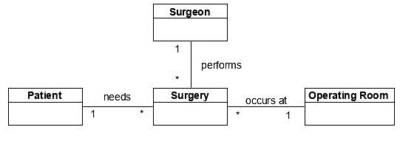The central class of the system is the surgery, which is the point of connection between the agents. The surgery is done to a patient, by a surgeon, at an operating room.

For more detailed version, please consult the **section** **20.1** in the annex.

# **Logical Model**

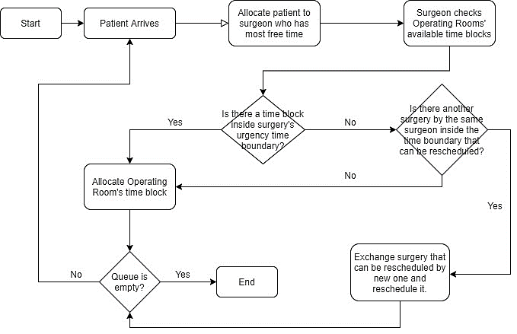In “Allocate Operating Room’s time block”, the allocation will take into consideration the scheduling procedure used. The existing scheduling procedures are available below, in the simulation scenarios.

For more detailed version, please consult the **section** **20.2** in the annex.

# **Coding**

The programming language we will use is **Netlogo**.

# **Data requirements (input)**

## **Data sources**

* Records from ERS (Entidade Reguladora da Saúde) [3].
* People personal experience obtained from a questionnaire.

## **Data collection methods**

* We sent a questionnaire to FEUP’s community to check what would be an acceptable waiting time for a surgery and how long people have had to wait for surgeries.
* Records from ERS (Entidade Reguladora da Saúde) [3].

# **Data requirements (output)**

## **Data analytics**

We will analyse the following variables:

* Average waiting time.
* Occupation Rate of Operating Rooms.
* Respect Rate of Urgency Boundaries.
* Rescheduling Rate.

We collected data by sending a questionnaire to FEUP’s community, to understand what an acceptable waiting time for a surgery is. On top of this, we will also compare our results with data collected from ERS (Entidade Reguladora da Saúde), to see if our system implements a better solution than what is currently being done in hospitals.

## **Data visualisation techniques**

* Charts to display how each of the variables above behave as the number of scheduled surgeries increases.

# **Simulation scenarios**

## **Reference scenarios**

The scenarios tested will differ according to the operating policies chosen to run the system. These are specified in the operating policies’ topic.

## **What-if scenarios**

* What happens to the average waiting time if the number of patients / surgeons / operating rooms increase / decrease?

## **Simulation plan**

We will calibrate the system with an initial amount of operating rooms, surgeons and patients representative of a real hospital. With this, we will test the different operating policies used to decide the surgeries schedules and find out what the most desirable one is.

Then, to see how changes in the initial values of the system affect the final results, the system will be run with different numbers of operating rooms, surgeons and patients. We will test the system many times:

* Increasing the number of operating rooms and maintaining the remaining variables, to check if an increase in operating rooms makes the system more capable of handling big amounts of patients while minimizing average time.
* Increasing the number of surgeons and maintaining the remaining variables, to check if an increase in surgeons makes the system more capable of handling big amounts of patients while minimizing average time.

# **Work Plan**

For more detailed version, please consult the **section** **20.3** in the annex.

# **References**

**[1]**

[*https://journals.lww.com/anesthesia-analgesia/Fulltext/1999/07000/An_Operating_Room_Scheduling_Strategy_to_Maximize.3.aspx*](https://journals.lww.com/anesthesia-analgesia/Fulltext/1999/07000/An_Operating_Room_Scheduling_Strategy_to_Maximize.3.aspx)

**[2]** [*https://www.sciencedirect.com/science/article/pii/S2351978917302020*](https://www.sciencedirect.com/science/article/pii/S2351978917302020)

**[3]** [*https://www.ers.pt/uploads/writer_file/document/2518/ERS_-_Tempos_de_espera_Mai.2019__publicar_.pdf*](https://www.ers.pt/uploads/writer_file/document/2518/ERS_-_Tempos_de_espera_Mai.2019__publicar_.pdf)

# **Annexes**

## **Conceptual Model**

## **Logical Model**

## **Work Plan**